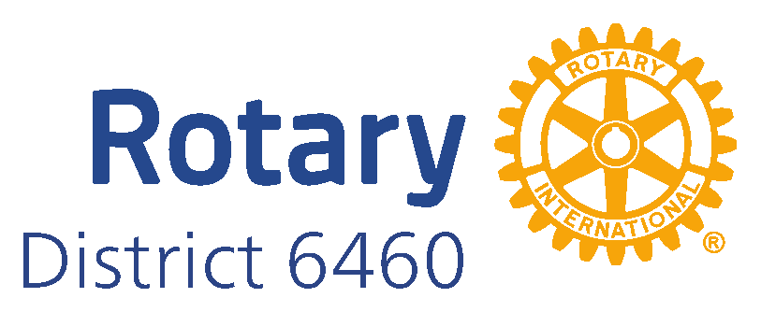
Apply for Rotary District 6460 Scholarships for 2025-2026

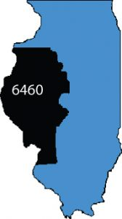
Rotary District 6460 is offering four District Scholarships ($3000 each) for undergraduate studies in the United States and one international scholarship ($18,000) for undergraduate or graduate studies abroad for the 2025-2026 academic year. Apply online for these opportunities at the web addresses provided below. The application deadline is midnight on May 31, 2025.

Rotary District Scholarships ($3000)
Apply online at https://www.rotarydistrict6460.org/foundation/districtscholars/. The scholarship provides $3,000 payable to a college, university or approved vocational school in or outside the District for tuition, fees, and/or books. Eligible students must live in, go to school in, or have graduated from a school in the District; have completed a minimum of 24 credit hours at college, university, or vocational school; must be pursuing a degree relevant to the seven Rotary International Areas of Focus; and meet all other criteria listed in the application.

Rotary William J. Menghini International Scholarship ($18,000)
Apply online at https://www.rotarydistrict6460.org/foundation/global-scholars/. The scholarship provides $18,000 payable to an international college or university for tuition, fees, books, and other college expenses. Eligible students must live in, go to school in, or have graduated from a school in the District; must have completed a minimum of 48 hours of university credits; must use the scholarship for a full academic year of undergraduate or graduate residential study in a country that the student has not lived or studied in before; must begin studies within 20 months after receiving the award; must serve as ambassadors of goodwill in the host country and share experiences with Rotarians, and meet all other criteria in the application. There are no restrictions on the field of study, but preference is given to students pursuing degrees relevant to the seven Rotary International Areas of Focus.

Direct questions to Dr. Bonnie Styles, Rotary District 6460 Scholarship Chair, bonstyles@yahoo.com

