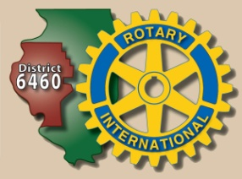
STUDY FOR ONE YEAR IN A FOREIGN COUNTRY
PROMOTE THE ADVANCEMENT OF INTERNATIONAL UNDERSTANDING, GOODWILL AND PEACE.
MEET STUDENTS FROM OTHER LANDS & EXPERIENCE THEIR CULTURE.
Club Step One: Send 2 sophomores to RYLA where they meet Inbound Exchange Students and learn about Rotary Youth Exchange and Interact. (April)
Step Two: Follow up on any inquiries of students 15.5-18.5 years old who wish to experience high school in another country. This opportunity is a scholarship sponsored by Rotary & qualifies for D Funds. The student pays for the flight, visa, passport. See www.csrye.org for more information and Outbound Handbook.
Step Three: Student fills out Preliminary Application, gives to club. Club interviews student.
Step Four: Application is forwarded to Pete Caruso, Outbound Coordinator
Step Five: Club appoints a YEO to help usher the student and parents through the year long process.
Cost: Club Commitment fee of $700 which includes administrative costs, membership in Central States Youth Exchange, payable in March of the exchange year.
Denmark
Belgium
Chile
Colombia
Indonesia
S Korea
Outbound Coordinator John Maguire tlmaguir@macomb.com
Barb Malany, Chair barbmalany@yahoo.com

